REQUEST FOR PROPOSAL FOR
OWNER’S ENGINEERING SERVICES

32 MWp solar PV Project in
Chad

July 2020

Dear Sirs,

Request for proposal to act as Owner’s Engineer (OE) in respect of a 32 MWp solar PV Project in Chad (the "OE RFP")

- Introduction

Djermaya Solar consists of the design, financing, construction, operation, and transfer after 25 years of a 32 MWp solar PV plant (Phase 1 of a 60 MW program), and the design, financing, construction, and transfer on completion of works of the associated interconnection infrastructure (the “Project”).

Development of the Project will be phased to gradually integrate renewable power into Chad’s national grid. The project is under a 25-year PPA with the Société Nationale d’Electricité (SNE), Chad’s National Utility Company. The Project will be the first privately owned utility-scale renewable energy project in Chad and will play a leading role in achieving Chad’s national development goals, liberalising the energy sector, mobilising private investment, and promoting the development of renewable energy.

The Project is being jointly developed by InfraCo Africa Limited (through Aldwych Africa Developments Limited) and Smart Energies International SAS, together the “Existing Shareholders”. Existing Shareholders have carried out a tender in view of selecting a Strategic Investor that will take a majority shareholding (70%) in the project and have entered a period of exclusivity with NEO Themis SARL in view of signing a Shareholders’ Agreement and a Subscription Agreement later in 2020. Existing Shareholders and Themis are referred to as the “Sponsors”.

The plant includes PV modules mounted on single-axis trackers, inverters, and step-up transformers. The interconnection infrastructure includes an 18 km 33 kV aerial double-circuit transmission line, two 33/90 kV step-up transformers at the Lamadji sub-station, and a 4.0 MWh battery energy storage system (BESS) located on the project site. Following the transfer of the interconnection infrastructure, the project’s O&M contractor will provide O&M services on the BESS for the utility.

The development phase is nearly completed, and project agreements are in mature draft form. Senior debt financing is being secured and financial close is expected to be reached in December 2020 followed by a 12-month construction period.

Existing Shareholders and Themis hereby invite interested firms to submit a proposal for Owners Engineering services to be executed during the construction and commissioning phase.

The competitive international tender will be carried out in accordance with the Private Infrastructure Development Group (PIDG) procurement rules.

Technical and financial proposal must be received before Friday 31st July 2020 at 18:00 (GMT + 1) and shall be sent by electronic mail to:

Mr. Malik Faraoun
m.faraoun@themisenergy.com

Mr. Alan Follmar
a.follmar@infracoafrica.com

Mr. Vianney de l’Estang
vianney.delestang@smart-energies.eu

Ms. Fatou Gaye
fgaye@infracoafrica.com.

In carrying out the Mandate the OE duty of responsibility shall be to Sponsors. All information presented herein should be considered and treated as confidential.

Intentionally Blank

- Project Description

The Project | - Design, financing, construction, operation, and transfer of a 32 MWp solar PV plant under a 25-year PPA.  - Design, financing, construction, and transfer at completion of works of an 18 km transmission line and 33/90kV step-up transformers.  - Design, financing, construction, operation for 10 years, and transfer at completion of works of a BESS.
Power Purchase Agreement | - A 25-year contract with the SNE for 100% off-take benefitting from take-or-pay provisions and a contractually agree tariff.
Project Sponsors | - InfraCo Africa Limited (InfraCo), a company incorporated in England and Wales (registered no. 05196897) whose registered office is at 6 Bevis Marks, London EC3A 7BA, United Kingdom.  - Smart Energies International SAS (Smart), a company incorporated in France, registered no. 822 367 975 R.C.S. Paris, whose registered office is at 20 rue Quentin-Bauchart 75008 Paris.  - Neo Themis SARL (Themis), a company incorporated in Morocco (registered no. 397415) whose registered office is at 162, rue Molière, 20050 Casablanca, Morocco.
The Project Company | - Djermaya CDEN Energy SARL (“DCE” or the “SPV”) is a company duly incorporated in Chad, registered no. RCCM TC/NDJ / 14 B 479, N’djamena, whose registered office is at Bureau 28, Radisson Blu Hotel, Quartier Sabangali, Cité du 1er décembre, N’Djamena, Chad.
EPC and O&M contractor | - Bharat Heavy Electricals Limited (BHEL), a company registered in India with company registration number 4281 of 1964 – 65 whose registered office is at BHEL House, Sirifort, New Delhi, India
Project Site | - 92-hectare property awarded by presidential decree located south west of Djermaya town.
Project Site Location | - Near the town of Djermaya in the Hadjer-Lamis region, about 30 km North from the capital city N’Djamena in Chad.  - Coordinates: 12.36343° N, 015.03698 ° E  - Elevation: 295m
Power Evacuation | - 18 km 33kV overhead transmission line to Lamadji substation
Project Timeline | - Expected NTP: Q1 2021  - Expected COD: Q1 2022

- Project Location

The Project is located near the town of Djermaya in the Hadjer-Lamis region, about 30 km North of the capital city N’Djamena in Chad. There are no obstacles in the vicinity or further constraints that can affect the plant’s construction and operation.

The site is located on a plain characterized by herbaceous vegetation that is abundant in rainy periods (from July to September) but which disappears the rest of the year. The Project site is relatively flat with a general slope running from northwest to southeast with a difference in elevation of about 3 metres. The elevation varies between 295.09 and 291.83 metres.

Figure 1: Project location

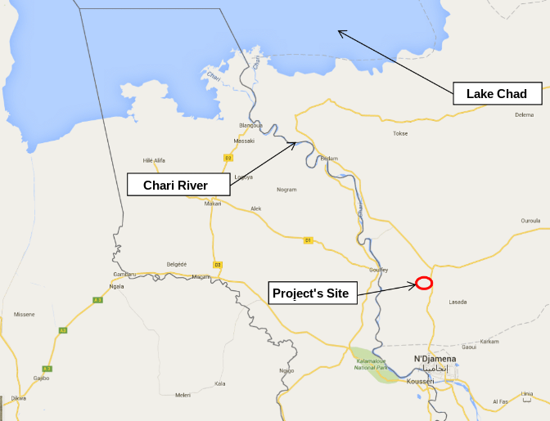

Intentionally Blank

- Key Technical Characteristics

4.1. General Technical features

Total capacity | 32MWp (27.5MWac)
PV surface | module area ~ 20 ha
Modules | Polycrystalline Si technology-BHEL L24270 320Wp
Inverters | Hitachi Central inverters in shelters Hiverter-NP201i-1250kW
First year yield | 68,006 MWh per year (P50)

Figure 2: Site Plan of the Project

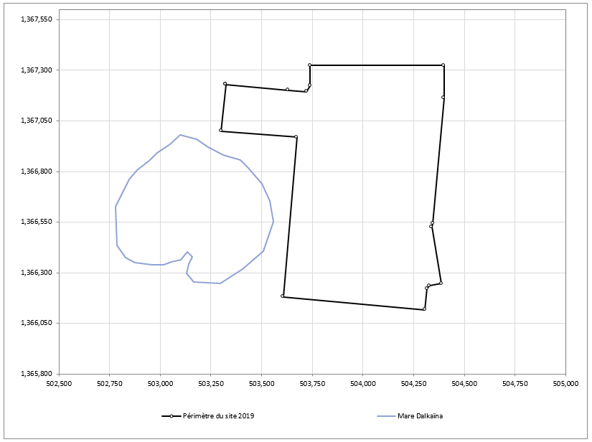

4.2. Equipment Review:

Photovoltaic module key technical features:

Manufacturer |  | BHEL
Number of Modules |  | 100320
Modules per string |  | 19
Nominal Power | Wp | 320
Tolerance |  | 0 to +3%
Cell type |  | Polycrystalline silicon
Voltage MPP | V | 37.06
Current MPP | A | 8.65
Dimensions (mm) | mm | 1966 x 986 x 35
Power Density (W/m²) | W/m2 | 165.08
Max System Voltage |  | 1000
Power Guarantee |  | 90% at year 10, 80% at year 25
Product Guarantee |  | 12 years
Product Certifications |  | Safety: IEC 61215, IEC 61730 1-2, IEC 61701

Anticipated Tracking System key technical features

Manufacturer |  | Scorpius Trackers Private Ltd
Structure |  | Single axis tracker
Range |  | ±45°
Tracking |  | ±1°
Maximum wind resistance | km/h | 150
Power consumption | KWh/MW/year | 300
Power Back-up | Days | 5 (backup with battery)
Backtracking |  | Yes
Warranty (years) |  | 5

Anticipated Inverters key technical features

Parameter |  | Value
Manufacturer |  | Hitachi Hi-Rel Power Electronics
Model |  | NP201i-1250kW
Type |  | Central inverter
Nominal AC power | kW | 1250
Output Voltage (V) | V | 350
Maximum efficiency | % | 98
Temperature range | °C | -5...+50 for full power
Material Warranty |  | Covered under EPC 10 years DNP
Product Certifications |  | Safety: IEC 62109, IEC 62116, UL 1741  Performance: IEC 61683, EN 50530

Anticipated Transformers key technical features

Parameter | Value
Manufacturer | Electrotherm (India) Lt

The transformers used for this project are oil-immerged 0.35/33kV transformers with a rated power of 2.7 MVA.

4.3. Yield Assumptions:

The yield assessment study was performed by DNV GL on behalf of Sponsors and by 3E as Lenders Technical Advisor.

Mean expected irradiation
 |  | DNV GL | 3E
Mean yearly horizontal irradiation | kWh/m2/yr | 2193 | 2189
Transposition Factor | % | 22.9 | 24.2
Mean yearly in-plane irradiations | kWh/m2/yr | 2695 | 2718
Mean Temperature | °C | 28.5 | 29.4

Yield assessment (P50)
 |  | DNV GL | 3E
System Peak Power (kWp) | kWp | 32,102.40 | 32,102.40
Average Performance Ratio - year 1 | % | 76.8 | 79.1
Specific Yield P50 | kWh/kWp/yr | 2070 | 2.149
Annual Yield P50 | MWh/yr | 66,456 | 68,9769
Total Yield P50 | MWh | 1,533,803 | 1,624,793

Expected Yields with Exceedance Probabilities
Probability of Exceedance | 1-year  Period | 1-year Period | 10-year Period | 10-year Period
P50 [yield MWh/annum] | 68,976 | 66,456 | 68,976 | 66,456
P90 [yield MWh/annum] | 63,961 | 59,813 | 64,201 | 59,598

- Project Development Status
5.1. Government Agreement / Permits
The project is at late stage development:
- The PPA was signed on 9th August 2018 and a first amendment has been reviewed with the Government.
- A put and Call Option Agreement (PCOA) has been drafted and agreed with the Government.
- The EPC and O&M contracts have been signed with BHEL.
- ESIA is approved by the Ministry of Environment and an environmental permit has been issued.
- The livelihood restoration programme is being executed and the first phase of compensation to project affected persons is currently being disbursed.

5.2. Financing Status

Djermaya Solar is supported by the African Development Bank ("AfDB"), which approved on 26th September 2019 senior debt financing for an amount of 18 million euros and a Partial Risk Guarantee (PRG). Proparco (branch of the French of Development Agency (AFD)) and Emerging Africa Infrastructure Fund (EAIF) have also been mandated in view of becoming senior lenders for a total combined amount of 19.7 million euros. The Project has also been granted a concessional loan of for an amount of EUR 6.35 million from the European Union through EU-Africa Infrastructure Trust Fund’(EU-AITF).

Lenders advisors are as follows: (i) 3E: Technical Advisor, (ii) Insuco: Environmental advisor, (iii) Clifford Chance: Legal Advisor, (iii) Indecs: Insurance Advisor (iv) Deloitte: Fiscal and Model Audit.

Financing documents are being drafted by Lenders. Financial Close is expected in December 2020.

5.3. EPC and O&M Selection
EPC and O&M Highlights
Following an international competitive bidding process, Bharat Heavy Electricals Limited (BHEL) has been awarded both EPC and O&M contracts.
BHEL will build the Djermaya 32 MWp plant, as well as the BESS, the transmission line and an extension of the Lamadji substation, on a fixed price, date certain turnkey basis with guarantees of plant performance.
Prior to the Taking-Over Date, BHEL will have to demonstrate the plant’s required performance. Liquidated damages will be payable for failure to achieve the performance guarantees. If performance fails to achieve a minimum level, the Owner will be entitled to reject the plant. The Time for Completion is 365 days with possible extensions in limited circumstances.
BHEL as the Operator will be present during testing and commissioning of the plant (i.e. during the Early Services Period which begins on the Effective Date of the Contract and ends at Taking-Over Date).
The contract is designed to be fully back-to-back with the PPA. In addition, penalties under the PPA are incorporated into the liquidated damages to be paid under the EPC Contract. All the Owner’s responsibilities in the PPA, if related to the EPC Contract, are addressed in the Contract.
BHEL Overview
BHEL was founded in 1964 by the Government of India in order to push the power generation installed capacity in the country to 100 GW by the turn of the century. BHEL is one of the largest engineering and manufacturing companies in India. As of 2018 the company employed 37,540 employees and is the second largest employer in the Indian capital goods industry. BHEL manufactures products and systems for a wide range of activities such as power generation, electrical transmission systems, renewable energy and energy storage, transportation, water management, oil & gas, and defence. Its industrial base includes 17 manufacturing units, 8 service centres, 15 regional marketing centres, and more than 150 project sites across India and abroad.
With respect to power, BHEL has an installed base of 183 GW of power generating equipment in India and abroad and currently has more than 6,000 MW of power projects being executed. BHEL is present in 83 countries and has contributed to the development of 11GW power generation capacity in overseas markets.
The EPC and O&M Contracts were signed on 31st March 2020.
- Project Schedule
- OE Selection: 31st July 2020
- EPC Notice to Proceed: January 2021
- Commercial Operations Date: January 2022

- Services to be rendered by OE

EPC Contractor will be retained with full responsibility for the design, manufacturing, construction, erection, commissioning and testing of all works required to substantially complete the Project, including civil works, mechanical works and electrical works, to the quality and standards, timeframe and budget as specified in the EPC Contract.

The main objective of the OE Services to be provided by the OE is to facilitate the timely and effective implementation of the EPC contract through assisting the Client:

- Ensuring the Contractors compliance with the technical provisions of the EPC Contract, advising the Contractor of any non-compliance and any rectification actions to be undertaken and monitoring implementation of such actions: and
- Ensuring site ESHS standards (as set out in Schedule 16 of the EPC Contract) are adhered to by the Contractor; and
- Monitoring and ensuring the standard of the construction and erection works confirms to international best practise
- With administration of the EPC contract and by advising the Client with respect to aspects which, in the OE’s professional judgment, may jeopardise the successful implementation of the Project; and
- Thorough reviewing, on a continuous basis, the EPC contract timetable; and
- With reviewing and monitoring aspects of the EPC contractor’s work, including design; QA/QC; (and manufacture, factory inspections and factory acceptance tests, and equipment delivery); construction and erection; commissioning and testing, as well as the associated documentation; health, safety and environmental issues and general contract administration; and
- In his dealings with local-and national parties in Chad and international financing institutions (IFIs) involved in the Project and others

Below is a list of OE tasks. The remuneration for OE will include living expenses as the Employer will not provide accommodation, local transport or meals to the OE staff.

During the course of the assignment the OE will:

- Set up Project Management Information systems
- Review EPC Contractor’s Monthly Reports
- Provide OE’s Monthly Progress Reports
- Assist Client in their dealings with Local- and National Parties in Chad including SNE etc.
- Assist Client in their dealings with Project Financiers and LTA,
- Arrange Project Co-ordination Meetings and Review Meetings
- Arrange Project Progress Meetings
- Monitor EPC Contractor’s Programme
- Verify Milestones
- Review Proposed Variations
- Process EPC Contractor’s Claims
- Assist in Resolving Disputes with the EPC Contractor
- Assist and monitor the implementation of E&S plans and the Contractor’s CESMP
- Review the Implementation Schedule (Project Milestones: planned vs actual)
- Validate Payment Milestones with EPC Contractor (including approving invoices and attachments)
- Prepare and maintain project risk assessment / mitigation plans
- Assist on behalf of the Client (whenever required to the FAT) and provide report.

During Pre-Construction Phase
- Participate in Project Kick-off Meeting,
- Review and provide a Pre-Construction Report with recommendations on:
  - Key Project Contracts e.g. PPA/Connection Agreement/EPC/O&M and verify that the arrangements contained within them are “back to back” and will advise the Project Company of any gap or inconsistence that may be present.
  - Plant Design and configuration both from construction, performance, and operability point of view (including respect of Grid Code and compliance of the design to the Grid Impact Study)
  - Quality assurance program of the EPC
  - Designing operation procedures
  - Yield and performance
  - List of suppliers and provide comments on their credentials (and quality)
  - Site conditions including geotechnical, topographical, and hydrological studies
  - Tracker design / structural analysis is adapted to the design wind speed / foundation design, and that corrosion study and wind tunnel model in view of approving the tracker make/design.
  - Interconnection Study,
  - ESIA Reports for the project site and transmission line, the Livelihood Restoration Plan, the Stakeholder’s Engagement Plan, the Contractor’s Environmental and Social Management and Monitoring Plan (CESMMP), and the Environmental and Social Action Plan (ESAP)
  - Overall Construction Methodology Statement
  - Construction programme
  - QC and QA Plans and Manuals
  - Key Subcontractors of EPC Contractor
  - Spare Parts- and Special Tools Lists
  - Testing (factory and Site) and Commissioning Procedures and Tests
  - ESAP
  - Contractor’s Construction permits required to conduct the Works
  - CPs for delivering the Notice to Proceed to the EPC Contractor are fulfilled
- Comment on the Contractor’s Project Management Plans, the Mobilization plan of Contractor’s personal and the management of local community (if any) by assisting to meetings with the Contractors and different involved entities). The OE shall review:
  - Interface matrix
  - Logistics plan including procurement and delivery of material
  - Mobilisation of the Contractor’s personnel
  - BESS management
  - Dispatch process
  - Insurance and liability matters
  - Weather forecasting system
  - Module cleaning system
  - Staffing plan
  - O&M manual
  - Training
  - Health and safety
  - Site infrastructure
- Prepare Notice to Proceed to EPC
- Preparing application for remaining permits to be obtained

During Construction Phase
- Create and maintain a virtual data room for project documentation
- Provide Construction Monitoring at Site (1 local Site Manager (electric engineer) permanently + 1 local civil engineer during civil works),
- Review of Design Drawings and Method Statements (All of the Class A and Class B Documents will be reviewed and approved for construction. Class C Documents will be for information and checked randomly. Maximum number of design drawings to be reviewed will be capped at 60%),
- Review compliance of the EPC Contractor to the EPC Contract, prepare replies to the Contractor in case of claims, notifications or variation orders.
- Review compliance of the Project Company with the PPA requirement, prepare replies to the off-taker in case of claims, notifications, variation orders, test completion certificates, project taking over certificate, and any other communication with the off-taker.
- Review monthly reports, invoices and milestones,
- Provide Head Quarter’s Assistance to the Site Team where necessary,
- Carry out Planned and Impromptu Quality Checks and Audits,
- Check Compliance with the Health, Safety, Environment, and Security (HSES) Manager
- Review Factory Inspections, Factory Acceptance Tests (FATs), and Witness FATs of Plant and Equipment
- Prepare monthly, quarterly and annual reports for lenders and shareholders on technical and E&S matters.
- Evaluate the completion of the Works before providing the EPC Contractor the Mechanical Completion Certificate.

During Commissioning Phase
- Review and Approve Training Manual and Operator Training Course
- Witness Commissioning Tests and Review and Provide Comments to the Commissioning Test Reports
- Supervise Final Inspection and Taking-Over CPs before providing EPC Contractor with the Project Taking Over Certificate
- Review and Approve As-Built Documents
- Review and Approve Statement at Completion
- Generate the Punch List items (if any) and follow up with the EPC Contractor on clearing the punch items
- Prepare a final report including a summary of planned vs actual for the following (non-exhaustive): Contract Price, execution duration, delay (if any), plant achieved performance values (i.e.: Guaranteed PR%), applicable LDs (if any), track sheet of variations (if any), track sheet of claims (if any), defects and remedies taken by the Contractor.

7.1. OE Team

For this assignment, the OE shall deploy a team composed of experienced personnel that have proven track records from similar power plant projects. To ensure that the assignment will be carried out to the highest standards, the firm that is selected will provide specialists for each field of expertise. The team has been selected based on the following criteria:
- International and African experience (CVs of key team members to be provided)
- Experience in sustainable development of power projects
- Excellent technical and analytical skill in areas relevant to this assignment
- Strong contractual and contract management experience
- Ability to communicate in English and French
- Ability to work closely with the Client at all stages of a project

During pre-construction period, it will be mandatory to make available an engineering consultant with experience in operating a solar PV plant.

The OE’s project organisational chart should be provided. Each member of the team shall be entrusted with specific responsibilities for delivering the assigned task.

The OE shall mobilize site personal including (a) the on-site Project Manager for the entire duration of the Works; (b) civil and electrical engineers for the entire duration of their relevant sections of the Works, (c) commissioning engineer for the entire duration of the commission phase till the Project Taking Over.
The OE team shall be provided with senior back office support made available during the entire project execution duration, the senior back office shall share the OE experience on similar topics seen during the execution of the Project for which the Project Company will require an advise.

Personal experience requirement:
- Project Manager: electrical engineer background with minimum 10 years’ experience in managing energy projects and minimum 5 years’ experience in solar PV projects;
- Electrical Engineer: minimum of 8 years’ experience required;
- Civil Engineer: min 10 years with experience in foundations/tracker installation and drainage;
- HSE Manager (on site): min 5 years of experience in HSE;
- Commissioning Engineer (on site): minimum of 10 years’ experience with minimum 5 years’ experience in commissioning of PV systems and minimum 2-3 years’ experience in commissioning of BESS systems;
- Contract/Commercial Manage (back office): Minimum of 7 years’ experience.

7.2. Representation

For the administration of the Agreement each party shall designate the official or individual to be his representative.

If required by the Client, the OE shall designate an individual to liaise with the Client's representative in the country of the Project.

7.3. Changes in personnel

If it is necessary to replace any person, the party responsible for the appointment shall immediately arrange for replacement by a person of comparable competence.

The cost of such replacement shall be borne by the party responsible for the appointment except that if the replacement is requested by the other party such request shall be in writing stating the reasons for it and the party making the request shall bear the cost of replacement unless misconduct or inability to perform satisfactorily is established as the reason.

The OE shall ensure that leave cover shall be provided for staff on site in case of absence, or if any of the OE’s staff are not available on site during his relevant phase of the Work, such cover shall be provided by an equivalent experienced engineer and shall be made aware about the historical of the Project specificities.

- Proposals
8.1. Contents of the proposal
The proposal shall be submitted in English and shall not exceed 20 pages in length. The proposal must address each of the following items:
- Confirmation that your firm will have no conflict of interest in acting for the Sponsor in this transaction.
- The proposal must clearly state that all information gathered in the course of fulfilling the scope of work is confidential, shall remain the property of the Owner, and shall not be disclosed except with the written permission of the Owner.
- The OE will be responsible for its staff to be covered by comprehensive medical insurance, emergency medical evacuation, accident insurance, and life insurance, sufficient to cover all potential claims.
- Ability to work fluently in English and French.
- The OE should specify its security policy particularly with regards any travel restrictions it may impose on its personnel for health and safety considerations. The proposal should take into account specific actions and restrictions relating to personnel security that apply in Chad.
- Relevant experience in relation to:
  - Power sector transactions in Chad and sub-Saharan Africa generally
  - Solar power plant with similar size
  - Private sector financing advisory in energy related projects
  - Other experience considered to be of relevance to the Project
- Organization chart (on site & off site), staffing arrangements and responsibilities including CVs of key team members from your firm indicating the level of personal involvement in transactions of the type described in Paragraph 4.1 (b) above, the physical location of such technical team.
- A fee quote in Euro (including VAT) shall be provided on the basis that Commissioning occurs within 12 months from EPC Notice to Proceed. The Fee Quote shall be provided for each of the following categories (as described in section 7), including maximum caps (to include travel and accommodation expenses) where applicable:
  - Project Information Management System
  - Pre-Construction Phase Works
  - Construction Phase Works
    - Site Supervision (planning of visits)
    - Design Review
    - Quarterly visits of Project Management and E&S teams
    - Project Headquarter Support
  - Commissioning Phase
Factory acceptance tests should be priced separately per visit.
- Payment terms and schedule.
- Hourly rates applicable to each person for “Additional Services”.
- The OE shall be liable to the Owner for manifest damage and/or injury which result from negligence and wilful misconduct and negligent acts on the part of the OE in carrying out of the Scope of Work, to the maximum amount of EURO 1,000,000 or three times the Fee (whichever is the higher). The OE must effect and maintain in place with a reputable insurance company annual professional indemnity insurance with a limit or not less than EUR 5,000,000 for a period of at least 3 years after the term of this Agreement.
- Comments and suggestions on the proposed scope of work including workable suggestions that could improve the quality/ effectiveness of the assignment
- The proposal shall remain valid for 9 months.

- Rules of the OE RFP

Sponsors are not bound to proceed with the Project, accept any proposal, or provide reasons for rejecting any proposal, and will not reimburse any costs associated with the preparation of your proposal.

Sponsors intend to evaluate each proposal on the basis of the experience of the team nominated to undertake the mandate, the proposed fee caps, the proposed hourly rates and any other circumstances that it considers relevant at the time of the evaluation.

- Selection Process

Sponsors will evaluate first evaluate proposals based on the technical offer. Only those proposals that meet a minimum score will be evaluated on the basis of the financial offer.

We look forward to receiving your proposal.

Yours sincerely,

Annex I
PIDG Procurement Policy

Per financial model base case

